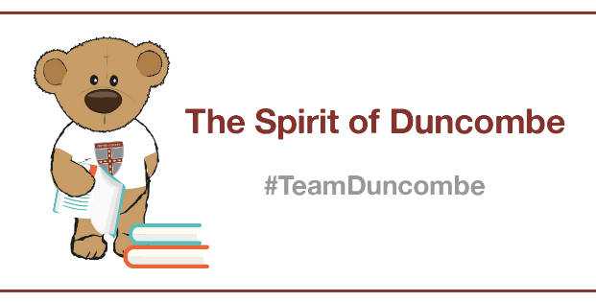
Drawing Masterclass with Team Duncombe’s James

Introduction
Hello everyone,
This masterclass is all about Drawing a 3D staircase
I have chosen this topic because it is a cool way to draw different styles and it helps you calm down and relax. Drawing also helps with your mental wellbeing.

Enjoy and stay safe.
Year 6, Team Duncombe

Masterclass Activity

- Drawing a 3D staircase
- You will need a piece of paper, a pencil, a rubber, a black pen and a ruler
- Draw your rectangle with a ruler.
- Draw thick lines then thin lines across the rectangles.
- Draw diagonal lines from near the end of the lines then slowly decrease it down so the stairs get smaller.
- Then rub out the access lines then get a black pen and fill in the blank next to the stairs.
- Then said in the stairs and voila your staircase is done.

Hints and Tips
Make sure you keep it in the lines and look at it from different angles.

I challenge you!
To see how fast you can do it.

