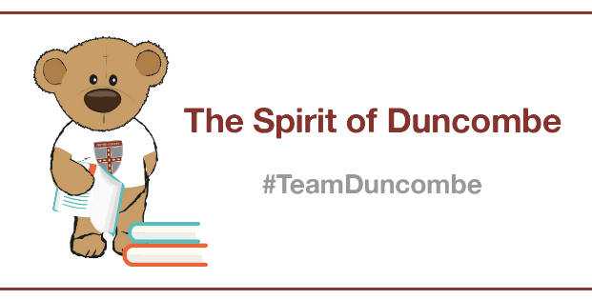

***Drawing a Face* Masterclass with Team Duncombe’s *Sophie!***

**Introduction**

*Hello everyone,*

*This masterclass is all about learning to draw a face’s proportions!*

*I have chosen this topic because I like to draw and this could really help you learn too!*

*Follow the steps carefully to create a face with realistic proportions.*

*Enjoy and stay safe.*

*Year 6, Team Duncombe*

**Masterclass Activity**

* 1) Draw the general shape of the face.
* 2) Draw a line in the middle of the shape.
* 3) Draw 2 eyes on the line and draw a hairline to your liking.
* 4) Draw a line down the middle.
* 5) on that line draw the nose by
* 6) under the nose, draw the mouth

And rub out the lines in the middle .

* 7) remember to draw in more detail than this!
* 8) **All done!**

**Hints and Tips**

* REMEMBER: The detail doesn’t have to be too complicated.